Assignment 16 - Blue Green Deployment

Step1

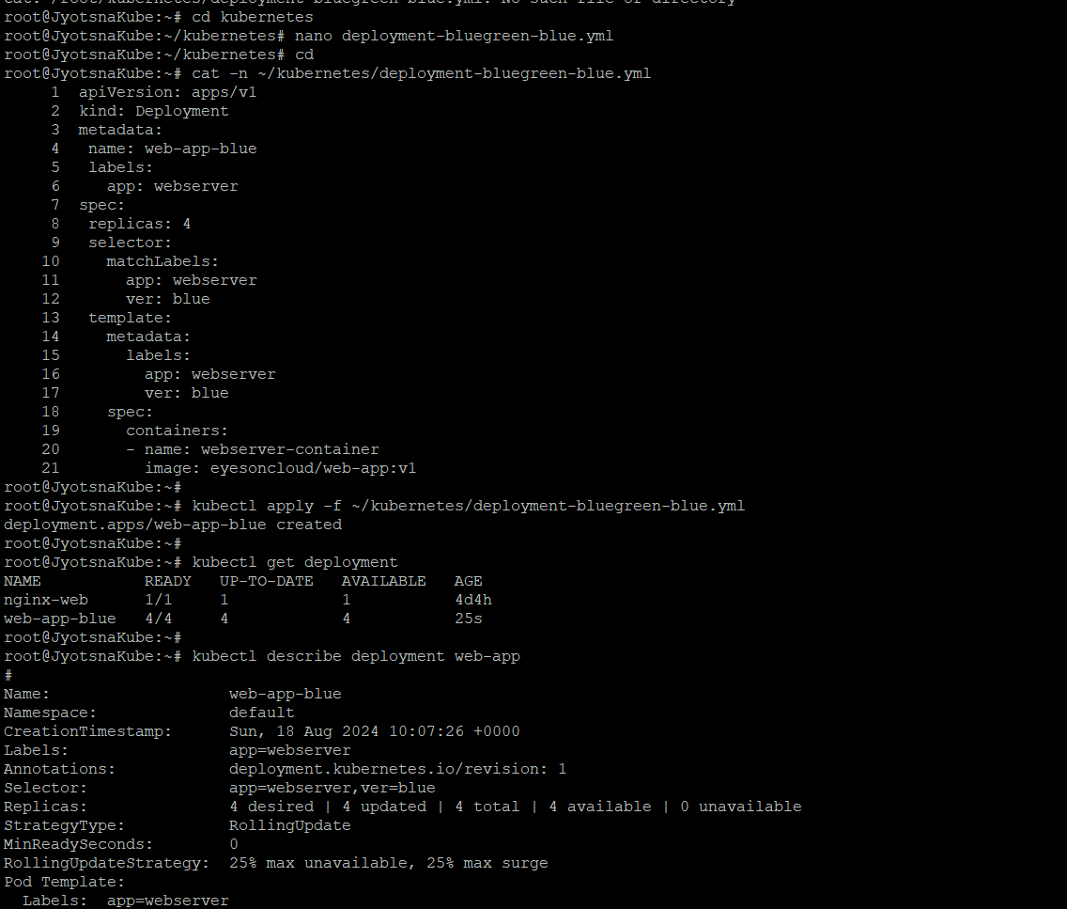

Step2

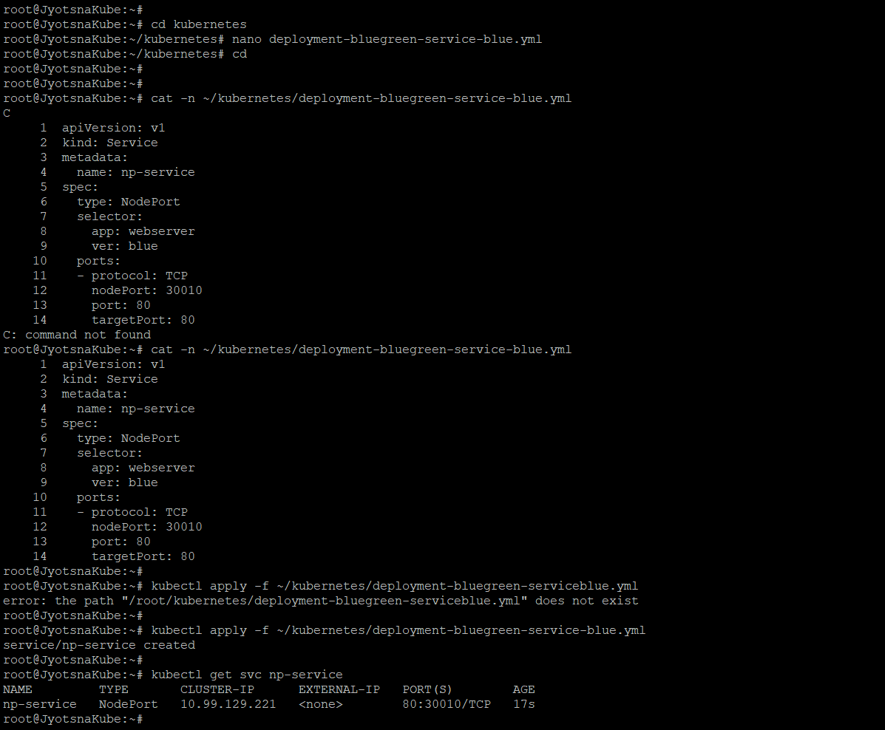

Step3

